**DAILY ONLINE ACTIVITIES SUMMARY**

|  |  |  |  |  |  |
| --- | --- | --- | --- | --- | --- |
| **Date:** | **22 June 2020** | | **Name:** | **KHATHEEJA SAFREENA.** | |
| **Sem & Sec** | **4th sem, 2nd year** | | **USN:** | **4al18cs037** | |
| **Online Test Summary** | | | | | |
| **Subject** | **----------------** | | | | |
| **Max. Marks** | **----** | **Score** | | **-----** | |
| **Certification Course Summary** | | | | | |
| **Course** | **INTRODUCTION TO R.** | | | | |
| **Certificate Provider** | **GreatLearning** | **Duration** | | | **5 hours.** |
| **Coding Challenges** | | | | | |
| **Problem Statement:1 program** | | | | | |
| **Status: Executed** | | | | | |
| **Uploaded the report in Github** | | **Yes** | | | |
| **If yes Repository name** | | [http://shafreenasharief / lockdown-coding](http://shafreenasharief / lockdown-coding" \o "http://shafreenasharief / lockdown-coding)  [http://shafreenasharief / locked-down--certification-course](http://shafreenasharief / locked-down--certification-course" \o "http://shafreenasharief / locked-down--certification-course)  **[http://shafreenasharief / Daily\_Report](http://shafreenasharief / Daily_Report" \o "http://shafreenasharief / Daily_Report)** | | | |
| **Uploaded the report in slack** | | **Yes** | | | |

Certification Course Details: (Attach the snapshot and briefly write the report for the same)

Coding Challenges Details: (Attach the snapshot and briefly write the report for the same)

#### CERTIFICATION COURSE SUMMARY:

#### Today I started new course INTRODUCTION TO INFORMATION R through

#### GREAT LEARNING the course is secluded for 6hrs. After the completion of course, certificate will be provided. I completed all the module .I attempted quiz ,which gave me a clear veiw about the topics that were thought and discussed.It consists of 7 modules which also include assessments.

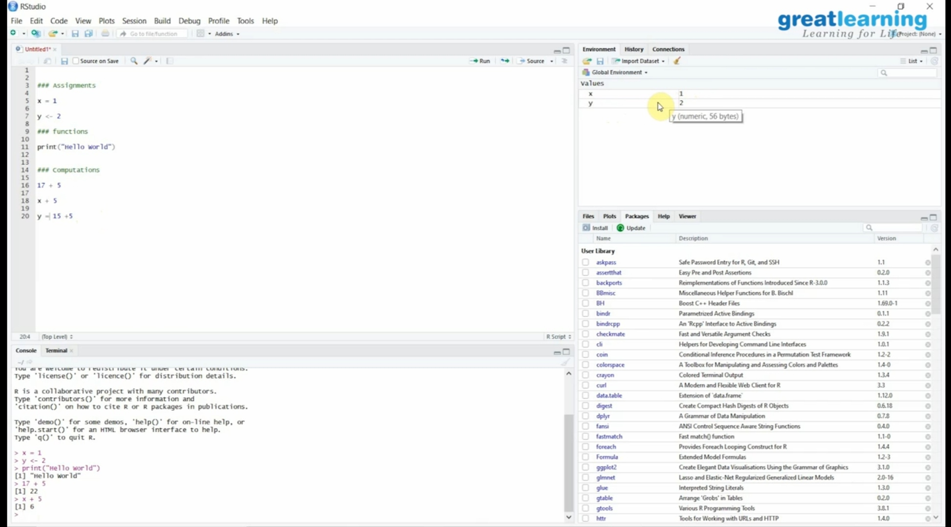

***CODING CHALLENGE :***

Today I solved 1 coding challenge,

1. **Write a Java Program for Modular Exponentiation**

Given three numbers x, y and p, compute (xy) % p.  
Input: x = 2, y = 3, p = 5  
Output: 3  
Explanation: 2^3 % 5 = 8 % 5 = 3.

Input: x = 2, y = 5, p = 13  
Output: 6  
Explanation: 2^5 % 13 = 32 % 13 = 6.

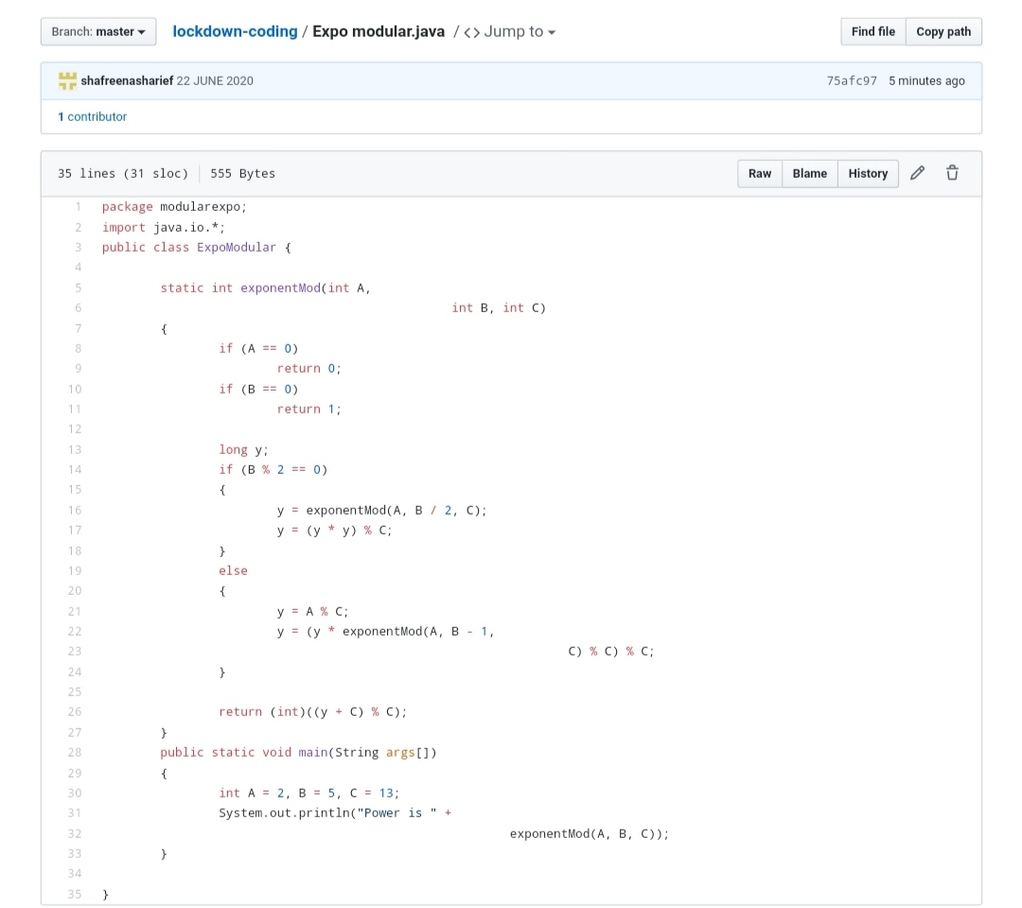

**SOLUTION** : I have uploaded the solution of the above 3 coding problems in my GitHub repository

[http://shafreenasharief / lockdown-coding](http://shafreenasharief / lockdown-coding" \o "http://shafreenasharief / lockdown-coding)

[http://shafreenasharief / locked-down--certification-course](http://shafreenasharief / locked-down--certification-course" \o "http://shafreenasharief / locked-down--certification-course)

[http://shafreenasharief / Daily\_Report](http://shafreenasharief / Daily_Report" \o "http://shafreenasharief / Daily_Report)